CLAY WORM COMPARISONS
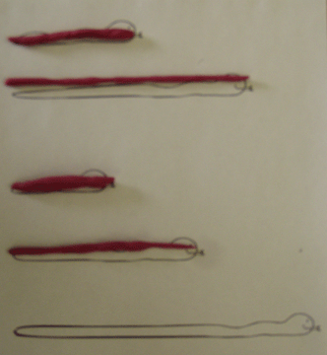

Objective: I can compare and order two or three concrete objects according
to length (longer/short than, or the same)

Materials: playdough or modeling clay, paper

Workstation Instructions:
- Roll the clay into worms. Lay a clay worm on top of each of the drawings.
- Take the clay worms off the drawings. Lay the worms on the sheet of paper in order from shortest to longest.
- Trace around your worms to make a permanent record of your results.
- Label one end of the paper SHORTEST. Label the other end of the paper LONGEST.

