Executive Function:
What It Is, Why It Matters, and How to Build It

Dr. Carrie S. Cutler www.carriecutler.com

Executive Function refers to the higher-level cognitive skills you use to control and coordinate your other cognitive abilities and behaviors.
How we organize our lives, how we plan, and how we then execute those plans are largely guided by our executive system.
Two Elements of Executive Function
- Organization includes gathering information and structuring it for evaluation.
- Regulation involves evaluating the available information and modulating your responses to the environment.

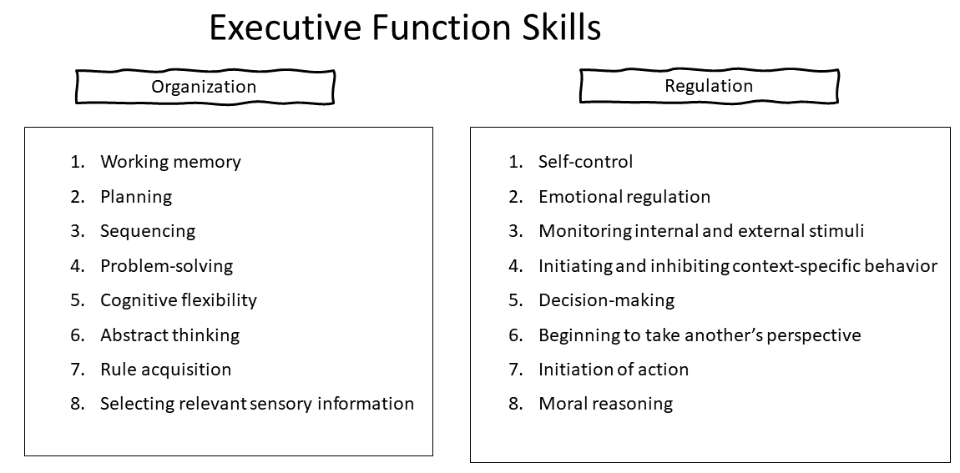
No One Is Born with Executive Function Skills, but Nearly Everyone Can Learn Them.
Our genes provide the blueprint for learning these skills, but they develop through experiences and practice.

Early Foundations—Supporting EF in Infancy
- Provide responsive relationships.
- Play peekaboo ton build working memory and self-control as baby anticipates the surprise.
- Provide consistency to help infants regulate their waking and sleeping cycles.
Tips for Supporting EF in Toddlers
- Provide simple cause and effect reasoning for desired behaviors
- Use suggestions and questions rather than commands
- Model language to assist understanding of emotions. “I bet that hurt your feelings.”
Preschool--The “High Season” of Imaginative Play
- Synchrony between the flourishing of make-believe play and self-regulation is no coincidence.
- Provide time, space, encouragement for dramatic play. Props are not as important as time. Encourage playful substitution, independent problem solving (with support), and lots of communication.

11 Intentional Ways to Support Focus and Self-Control
1. Promote children’s self-generated strategies for bringing themselves under control. Notice what children already do to manage their behavior, like moving to another space when there is too much noise. Encourage this strategy by creating special quiet spaces where children can calm down.
2. Help children think of ideas for bringing themselves under control. Invite children to think of strategies they can use when they are frustrated or angry to manage these feelings. Write the ideas down and remind children about them at times when they need to use self-control.
3. Play games that have rules. Simon Says requires children to focus, remember rules, think flexibly, and control their behavior. For added challenge, play Simon Says Do the Opposite. For instance, when you say, “Touch your toes,” children should touch their heads.
4. Play games that require children to pay attention. Play rhyming games, like “I am thinking of an animal with a name that sounds like pat.” Play word games, like “I am a fruit, and I start with the letter R. What am I?” These games support listening, focus, and divergent thinking.
5. Read stories in ways that encourage children to listen. When reading a familiar story or singing a favorite song, stop and ask children to finish the sentence or verse. Try singing different words to a song, like “Row, row, row your chair” instead of “Row your boat.” Do the children correct you?
6. Play sorting games with changing rules. Invite children to put away toys and supplies by type and return them to their proper homes. Try switching up the rules too—ask children to sort toys first by size or color, and then sort them back to where they belong.
Clean Up Sorting Song

- Let’s pick up the blue toys, the blue toys, the blue toys. Yes, let’s pick up the blue toys. Let’s put them away.
- Let’s pick up the crayons, the crayons, the crayons. Yes, let’s pick up the crayons. Let’s put them away.

- Can you find a square, a square, a square?
Oh, can you find a square and put it away?

7. Have children set goals or make plans, follow those plans, and then discuss what they accomplished. Have children make “play plans” with drawings or picture cards. What area of the room will they play in first, and what will they do there? Later, talk together about what worked, what didn’t work, and what to try next time.
8. Giving Choices. Preschool-age need practice to control emotions, manage interactions, and problem solve.

- Give choices among social and learning activities
- Support complex dramatic play
- Encourage independent problem solving
- Don’t rescue too quickly

9. Help children find and use strategies to delay gratification. While waiting:
- Sing a favorite song, think about fun things, or play I Spy or the ABC game with a friend.
- Use Guided Meditation: Draw children’s attention to parts of the body, instructing them to tense each part for two to three seconds and then relax with an exhale. Lastly tense and relax the entire body with an exhale.
- Emulate the teacher. Children learn from what they hear you say! “I really want that my snack now, but I am going to wait until after lunch.” “This line is really long, and we have been waiting for such a long time. I just need to be patient.”
10. Reinforce inhibitory control. Teach children to go peacefully back to building with blocks after their tower is knocked down, (“Oh well” shrug, rebuild). Play games that involve stop and go directions like Red Light/Green Light and Musical Chairs. Search online: Freeze Dance
11. Practice cognitive inhibitory control (avoiding calling out). Instead of shouting out or raising hands, use Thumbs Under Chins as a signal.
Four Other Areas of Executive Function and How to Help
- Working Memory Games

- Picnic Time. Tell child 3 things to collect for a picnic. Have them collect the items (or pictures of items) and bring them to a picnic rug.
- Memory and other matching games.
- Word list games. “I went to the shop/zoo/beach and I saw….”.
- Get the Loot. Pretend to be pirates. Set up two pirate ships with pictures of items for the ‘loot.’ Tell child 2 things to take from the other pirate ship. Child repeats the things they need to get 3 times before they get it. Slowly increase the number of items.

- Cognitive Flexibility. When you switch your attention from one situation to another, follow a new set of rules, or adjust your priorities as things change, you are using cognitive flexibility. How to help: dramatic play, play games where they work on opposites (like dancing slowly to fast music and then dancing fast to slow music).

- Staying Focused on a Goal. True focus means being alert and engaged and knowing where to direct your attention despite distractions. How to help: play games that involve paying attention to details like (I Spy), have children put away their backpack and lunch boxes and manage classroom materials.

- Following Multi-step Instructions
- Tell children the 3-step direction out loud (without the visual present).
- Show the pictures.
- Say the 3-step direction again while they’re looking at the directions.
- Then have them follow the steps.
- If they need to use the visual aid for completing the task, that’s fine! But try to fade the visuals back as quickly as possible.
Tips for Kids with Learning Differences
- Catch brain off guard and reboot it. Sing! Wiggle! Tell a joke! They’ll be back with you.
- Buddy up.
- “Watch the girls.” But remember: Peer modeling doesn’t work if the teacher takes over all the EF spaces.
- Use few words (economy of language) -- https://ifwelearndifferently.com/author/gayle-fisherusa-net/
- Use humor (not sarcasm or put downs) to diffuse situations, help child build self-control, and humanize.
- Gradually release so children progressively manage more and more aspects of their lives.
- Small groups, individual play with materials that respond to an individual child’s interests, and a quiet area are all elements of an environment that supports DLLs as they focus on learning and on learning a new language.

